Groups:

Peter Sulzen

Tommy Anastasios

Erin Wills

Topic: Election Data

Sources: Excel Sheet of X columns and Y rows for __ sheets. Obtained from ___

Graphics

* Bubble Chart of republican and democratic representatives plotted on an X and Y axis based on status of their district. Selection of buttons or the axis label changes the graph configuration.
* Radial/Branching diagram that shows visual representation of who holds elected office. Hovering over the block provides info about district/representative.
* Line Chart – able select the district to show voting patterns.

Deployment

* Postgres Database run on Heroku
* Flask App

User Interface:

* Single Page
* Bootstrap or Foundation
* Broken into sections
  + Party Makeup of government by office
  + Relationships of district stats and their district party affiliation
  + Changes in district affiliation over time
* Sample images of interesting charts with short blurbs that are positioned on the page by masonry.

Type of Charts

Bubble/Scatter Plot

* Bubbles represent states/districts and are Blue/Red based on Elected Official
* X & Y:
  + X: % Margin of Victory, X% - 50%, this number could be negative if both candidates did not get a plurality of the vote
  + X: % of Vote
  + X: Total Votes
  + Y: District Racial/Ethnic (% Black, etc.)
  + Y: District Education (% college degree)
  + Y: District Median Income
  + Y: District Youthfulness (1 – ACS Voting Age Population/Census Total Population)

Note: I don’t think it matters which one is X or Y

Maybe a filter could be added to show only records of representatives with X years experience, representative race/ethnicity, age, gender, sexual orientation

Radial Chart

Each region is either blue or red based on party

Inner Circle represents Federal President, next circle is Federal Senate, outer circle is Federal House. Each state representative is aligned in a column. It would be cool if the data for governor, state senate, and state house could be added. This would visually show political divides.

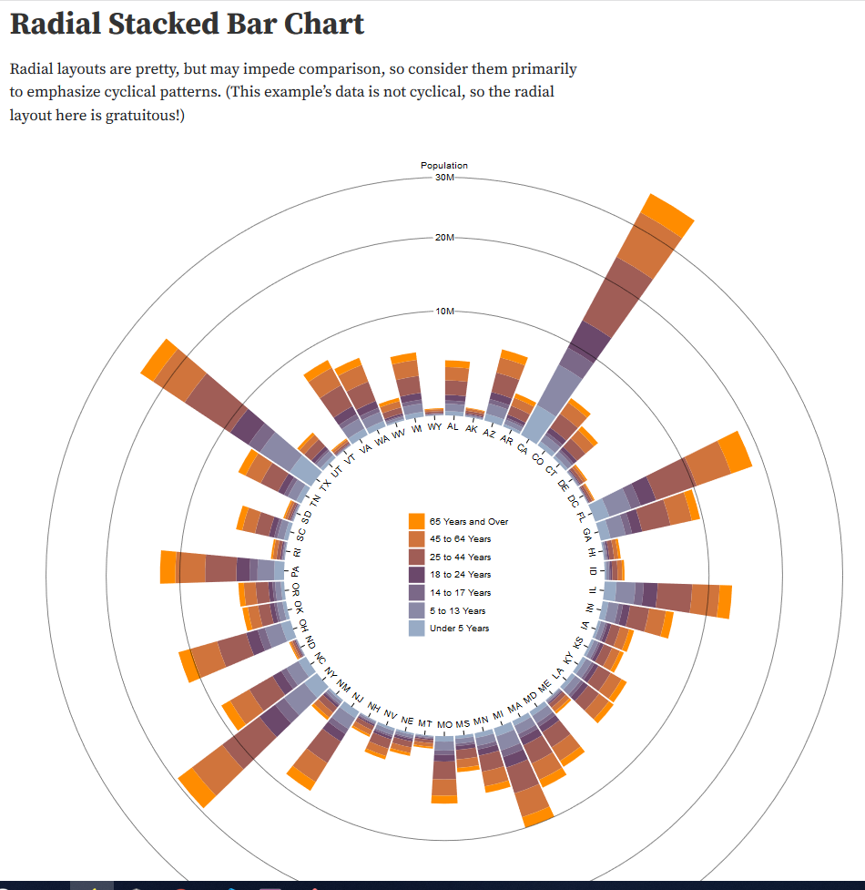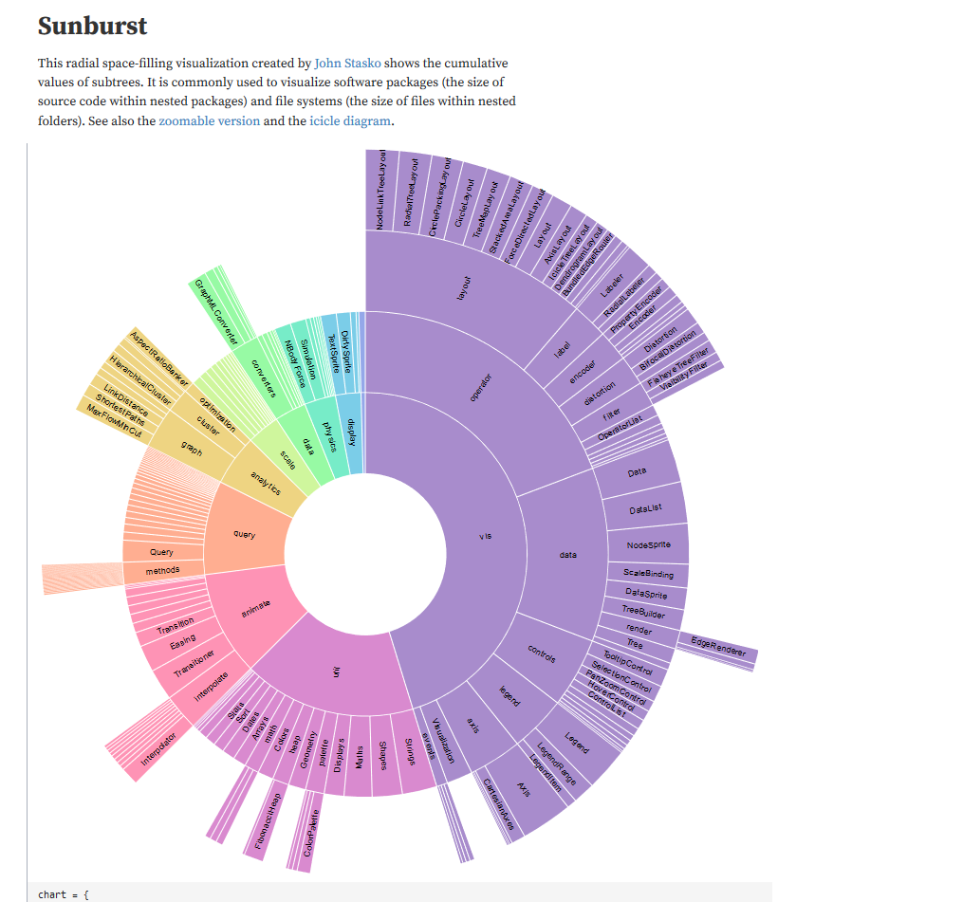

An alternative is a branching diagram

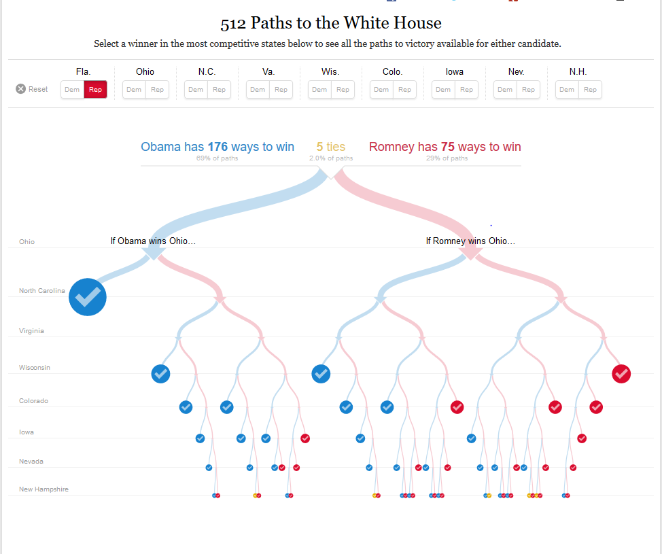

Line Charts

* Use the Election data per year and maybe bars showing total voter turnout (we need to check to see if we have the number of votes cast in each election
* X: % 0f Votes, Total Voters
* Y: Year
* Line Color – represents office
* Interaction: set a filter???